Source 1: Topography of North Dakota
Directions: Label the following terms on the map below:
*Missouri Escarpment *Missouri Plateau *Central Lowlands *Great Plains
*Upper River Basin *Drift Prairie *Red River Valley

________________________
This steep slope is called the…
________________________
______________________
or
______________________

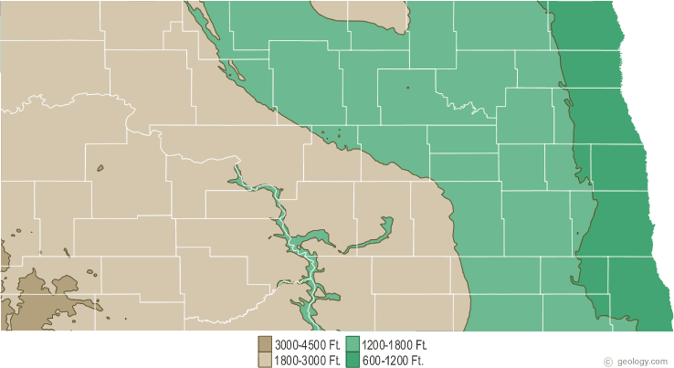

________________________

________________________

________________________

Source 2: Climate of North Dakota
Read about the climate of North Dakota and draw a picture in the box below. Then, choose three words to describe your picture and the climate of North Dakota.
Illustrate North Dakota Climate: | Three Words to Describe North Dakota Climate:

Source 3: East to West Migration
Many of the Plains Indian tribes originally were from the Great Lakes area of Minnesota. Extreme weather changes and conflicts with other tribes led to westward migration into North Dakota.
Step One: Using your knowledge of North Dakota Topography and weather, predict whether the statements below describe life in Minnesota or North Dakota.
Step Two: Then check your predications using the reading titled “East to West Migration”.
*Expert canoe-men *Expert horsemen *Wore hard sole moccasins *wore soft-soled moccasins

*ate fish and wild rice *ate buffalo meat and tipsin roots *more nomadic *more sedentary

*used long bows *used short bows *slept in hide tipis *built bark covered wigwams

*made sugar from box elder sap *boiled maple sap into sugar *Lived in one place year-round

*traveled to follow herds of animals and seasons

Forest Life in Minnesota | Plains Life in North Dakota

Sources 4: Regions and Tribes
Step One: Choose a region to focus on: _________________________________________________
Step Two: Choose a tribe to focus on: ___________________________________________________
Step Three: Use source four to find details about the tribe. Takes notes in the box.
Notes on the Tribe

Step Four: Make Connections
- To and from where did your tribe migrate? What were the reasons for migration?

- What do you think would be the biggest challenges or obstacles in migration for your tribe?

- What changes or adaptations would your tribe have made after moving to this new location? (This can be answered using the reading or just your knowledge from other sources.)

Step Five: Step into the Past
On a piece of notebook paper, write a diary entry as a member of the tribe you researched. Add in details about:
- Experience of the migration
- Climate of the old location
- Climate of the new location
- Changes or adaptations the tribe made

